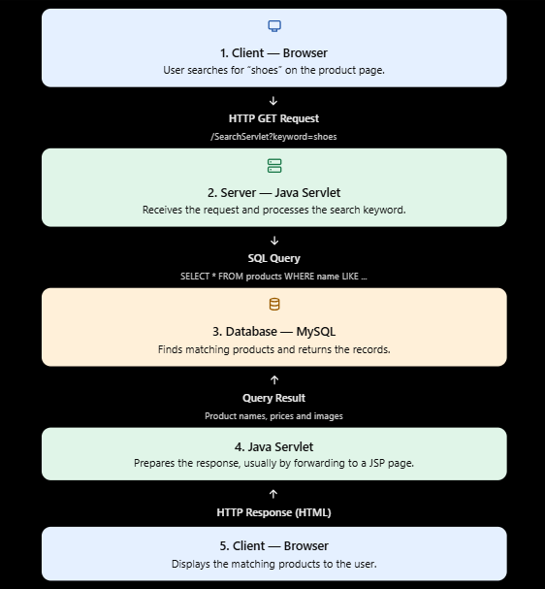

__________________________________________________________________________________
Static webpage | Dynamic webpage
Content usually stays the same until the file is edited. | Content can change based on user actions or data.
Often uses HTML and CSS without a backend. | May use Java Servlets, JSP, databases and JavaScript.
Example: a basic About Us page. | Example: Instagram's personalized feed, likes and comments.

__________________________________________________________________________________
Data flow in a BookMyShow-like ticket booking system
- User selects a ticket: The user chooses a movie, theatre, showtime and seats in the browser.
- HTTP request: The browser sends the booking details to the Java Servlet using an HTTP request, such as a POST request.
- Database processing: The Servlet validates the details, checks seat availability and saves the booking in the database if the seats are available.
- HTTP response: The Servlet returns a confirmation or an error response, and the browser displays the booking status to the user.

